References
- https://hackaday.io/project/12876-chronio
CPU specs (Atmega328p)
up to 16MHz (16MIPS)
32K flash
1Kb EEPROM
2Kb internal SRAM
1.5mA @ 3V 4MHz
Idle: 1uA @ 3V
- https://www.sensorwatch.net/
- https://lilygo.cc/products/t-watch-2020-v3
- GPS code in this repository
- https://youtu.be/BpyH32n6yyY?t=390 smartwatch antennas
-BMM150 I2C addressing:
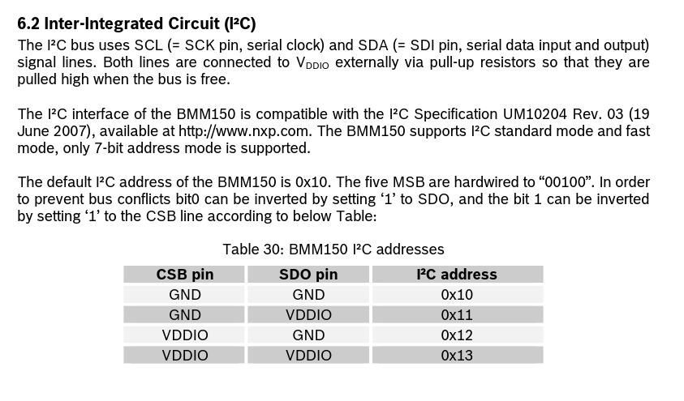
- an4760-quadspi-interface-on-stm32-microcontrollers-and-microprocessors—stmicroelectronics.pdf quad spi configuration
- https://www.murata.com/en-us/products/sound/library/basic/circuit piezo circuitry
GPS interface: https://content.u-blox.com/sites/default/files/u-blox-M10-SPG-5.10_InterfaceDescription_UBX-21035062.pdf
https://www.sparkfun.com/sparkfun-gnss-receiver-breakout-max-m10s-qwiic.html more max-m10s info

https://hackaday.com/2025/08/10/a-solar-only-battery-free-device-that-harvests-energy-from-a-bpw34-photodiode/ photodiode charge harvesting

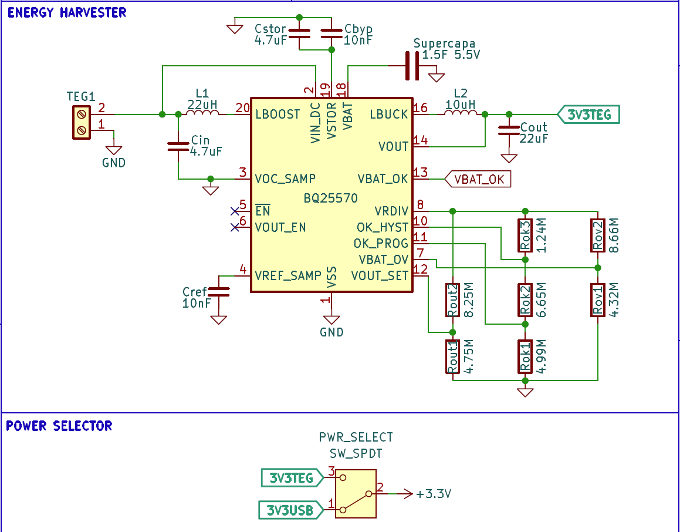
Rout1 = 4.75M
Rout2 = 8.25M
Rov1 = 5.62M
Rov2 = 7.32M
photodiode math:
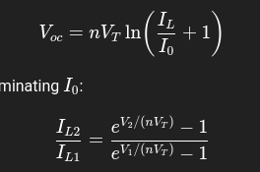
STM32WB QFN48 RF reference:
MAX-M10S example circuit:
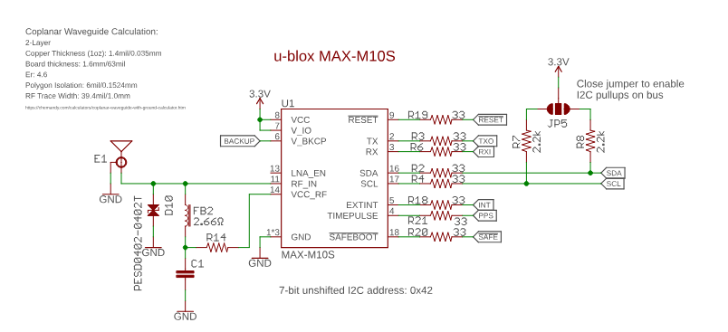
stm32wb RF OUT
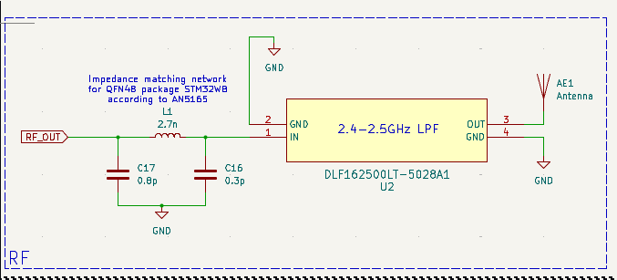
RF Analysis software: https://www.ansys.com/academic/students/ansys-electronics-desktop-student
https://www.youtube.com/watch?v=Ie-tRF0AUOY

https://www.ardusimple.com/how-to-use-ardusimple-kit-and-u-center-in-ubuntu/

copper foil tape w/ conductive adhesive: https://www.adafruit.com/product/1128 on the ground pad

glass panes: https://allwatchparts.com/10mm-Flat-Rectangle-Mineral-Glass-Crystal_p_3009.html

Xcode Cloud – 100 hrs cpu time for free w/ developer account

Electrical Components:
Photodiode: BPW34

Harvester: bq25570

Battery:
CR2032 – 230mAh
CR2450 – 610-620mAh, LOWER current capabilities, 1.8mm thicker
LIR2450 – 120mAh – high current capability, shorter lifespan
RJD2450 – 200mAh 5.5mm
RJD2440 – 150mAh 4.5mm

Display: LS011B7DH03 - SPI
160x68 monochrome
1Hz signal gen, 50% duty cycle
SiT1534 – ~1uA
SIT1534AC-H5-DCC-00.001E for 1Hz
viewing exposed pins, 1 on left, 10 on right (screen above pins)

Display connector:
68711014522 – connector w/ FPC folded in on itself like a Z
5051101092 – BOT
These appear to be too bulky, or hard to use because of the solid section of the display’s FPC connector that will stick into the flash memory chip
Need TOP connection: eg, MOLEX 5034801000 to fold in a C
1-2328702-0 – compact, both-sided

MCU: STM32L4 series
STM32U0 series – STM32U083CCUx
STM32WB series – BLE radio mostly shut off but can be powered on for data transfer
-test pwr management with PB boards
(?)voltage measurement requires ADC, make sure it turns off before

RTC: STM32 internal RTC, external 32kHz crystal osc

GPS: L76K
MIA-M10Q – via UART – at 3V, 8.5mA for roughly 30 seconds
-28uA in backup mode (!!!) but enables faster fixing
-hard to find, expensive
MAX-M10S – bulkier package but cheaper and more available
-~32uA backup mode. Power backup via GPIO?
-says up to 100mA pulse inrush on startup, circumvent with capacitors
-”10 ms pulse at 100 mA, Q = 1 mC. ΔV of 0.5 V at 3.0 V supply, required C = Q/ΔV = 1mC / 0.5 V = 2 mF (2000 µF)”

GPS Switching:
FemtoFET (e.g., TI’s CSD23381F4) – very low leakage
pFET, high side switching

?GPS ANTENNA: Small ceramic?
- https://www.elecbee.com/en-2765-pcbgps-gsm-internal-antenna-reference-design-with-ipex-rg174
- https://www.adafruit.com/product/2460

Piezo Buzzer: PKMCS0909E4000 – expects 1.5V 0-peak, can probably be driven by GPIO

Power management in case of rechargeable battery: axp202 (?)

Analog movement: Miyota 5Y26 (two hands) 5Y36 (hr/min/second hand) – 0.9uA
-the movement with the second hand is a bit taller than the other
-Requires ultra low Iq LDO to be taken to 1.5V from 3V coin cell
-STLQ015 – 1.0uA Iq, has 1.5V variant (STLQ015M15R)

Flash mem?:
-W25Q128JWPIQ (128Mbit NOR flash) – should be clocked at 1MHz for power purposes
-MX25R6435F (64Mbit)

Barometer: BME280 – 1uA

Accelerometer: LIS2DW12 (1uA @ 12.5Hz) – I2C – 1uA

Magneto: BMM150 – 170uA in low power mode, shut off via GPIO or 1-3uA suspend mode
lis3mdl – ST’s equivalent, has adafruit breakout board for testing

Rotary encoder/switch: EC06 https://www.ttencoder.com/sale-47093863-miniature-incremental-rotary-encoder-incremental-push-button.html

Desired Features:
- Analog watch face
- Photodiode energy harvesting
- STM32:
Timer
Alarm(s)
Stopwatch (ms)
- STM32 BLE:
Transfer GPS data to/from phone
- LED lighting button – CANNOT BE POWERED WITH PC13/14/15
- GPS
Elevation
Location
Auto-time-set
- Accelerometer
Step count(?)
Directional tap navigation
- Magnetometer
Compass
- Environmental sensor
Pressure
Temperature
Humidity
- Flash memory
GPS route recording
GPS navigation from phone/computer

Body Manufacture:
3D print as prototype (san mateo county library? bangus)
JLCCNC
https://kenlywarren.com/casting-service/ - jewelry casting
- finished with physical vapor deposition?
Glass: https://www.watchmaterial.com/square-watch-crystal-mineral-glass-polished-edges/

